Suggested Solution to
Assignment 3

- Define and describe the differences between hubs, switches and routers.

A hub is a multi-port repeater. It is a level 1 device. It just repeats whatever is sent to one of its ports, to all the other ports. It does not do any switching or routing operations.
A switch is a level 2 device which sends the incoming frames to just one of its ports based on the address contained in the frame. It cannot handle IP addresses.
A router is a level 3 device which can route the given packet to a particular subnet on one of its interfaces or to another router which is capable of sending the packet to the destination. It actively decides the interfaces and routers to which the packet must be sent. The operation of a router is more complicated than a switch and usually involves Routing tables.

- Briefly describe how a host or router can determine the MAC address of another host B when knowing B’s IP address? (Hint: ARP protocol)

The MAC address of a host can be resolved using the IP Address Resolution Protocol (ARP). The host or router broadcasts an ARP request message with IP address of host B. Host B then responds with an ARP reply message to router stating its physical address. The whole sequence of events is outlined in The TCP/IP Guide ( http://www.TCPIPGuide.com) and is reproduced below:
- Source Device Checks Cache: The source device will first check its cache to determine if it already has a resolution of the destination device. If so, it can skip to the last step of this process, step #9.
- Source Device Generates ARP Request Message: The source device generates an ARP Request message. It puts its own data link layer address as the Sender Hardware Address and its own IP address as the Sender Protocol Address. It fills in the IP address of the destination as the Target Protocol Address. (It must leave the Target Hardware Address blank, since that it is what it is trying to determine!)
- Source Device Broadcasts ARP Request Message: The source broadcasts the ARP Request message on the local network.
- Local Devices Process ARP Request Message: The message is received by each device on the local network. It is processed, with each device looking for a match on the Target Protocol Address. Those that do not match will drop the message and take no further action.
- Destination Device Generates ARP Reply Message: The one device whose IP address matches the contents of the Target Protocol Address of the message will generate an ARP Reply message. It takes the Sender Hardware Address and Sender Protocol Address fields from the ARP Request message and uses these as the values for the Target Hardware Address and Target Protocol Address of the reply. It then fills in its own layer two address as the Sender Hardware Address and its IP address as the Sender Protocol Address. Other fields are filled in as explained in the topic describing the ARP message format.
- Destination Device Updates ARP Cache: If the source needs to send an IP datagram to the destination now, it makes sense that the destination will probably need to send a response to the source at some point soon. (After all, most communication on a network is bidirectional.) As an optimization, then, the destination device will add an entry to its own ARP cache containing the hardware and IP addresses of the source that sent the ARP Request. This saves the destination from needing to do an unnecessary resolution cycle later on.
- Destination Device Sends ARP Reply Message: The destination device sends the ARP reply message. This reply is, however, sent unicast to the source device, as there is no need to broadcast it.
- Source Device Processes ARP Reply Message: The source device processes the reply from the destination. It stores the Sender Hardware Address as the layer two address of the destination, to use for sending its IP datagram.
- Source Device Updates ARP Cache: The source device uses the Sender Protocol Address and Sender Hardware Address to update its ARP cache for use in the future when transmitting to this device.

- Spell out and define/describe CSMA/CD.

CSMA/CD stands for Carrier Sense Multiple Access/Collision Detection. It is a technique for handling channel allocation in layer 2. When there are multiple devices connected to the same physical media, more than one might transmit at the same time causing disruption. To avoid this, there must be a method to decide who can transmit. CSMA/CD is one solution.

In this method, the device will sense the channel, which is - listening to the channel before transmission. If there is some data being transmitted, the device will wait a random amount of time before trying again. If there is no data being transmitted, the device can proceed. It might so happen that two devices start transmitting at the same time. If such a situation occurs, a jamming signal will be sent to all devices in the network and the two devices will detect the collision. Both of them will stop transmission, wait for random amounts of time (hopefully different) and attempt to retransmit. If there is a collision again, the device will wait for a longer period of time and then try again. If collisions keep repeating, the frame will be discarded after a set maximum number of attempts.
- Refer to the following diagram. Host_A is attempting to contact Server_B. In this process, Host_A will generate a packet with the destination IP address of which device (e.g., Router_A or server_B)? Host_A will then generate a frame with the destination MAC address of which device (e.g., Switch_A, Router_A. or Server_B)? Briefly describe the difference between IP address (IPv4) and MAC address.

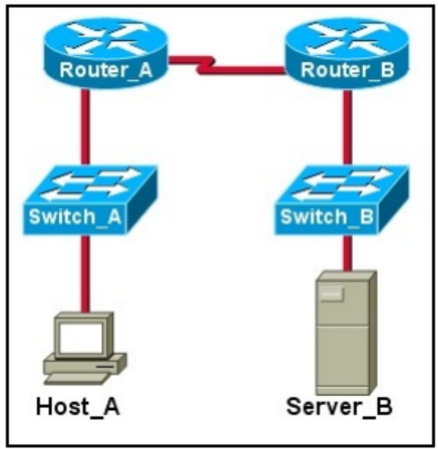

In this process, Host_A will generate a packet with the destination IP address of Server_B. Host_A will then generate a frame with the destination MAC address of Router_A.

Differences between IP address and MAC address:
  - IP address is 32 bits while MAC address is 48 bits;
  - IP address is usually expressed in dotted decimal format while MAC address is usually expressed for humans in hexadecimal format;
  - IP address is hierarchical and not portable. It depends on IP subnet to which node is attached. MAC address is flat and portable. Each LAN card has a MAC address, and this address does not change if the card is moved from one LAN to another.

- Spell out and define VLAN. Describe the benefits of implementing VLANs.

VLAN is Virtual Local Area Network. A VLAN is a switched network that is logically segmented on an organizational basis, by functions, project teams, or applications rather than on a physical or geographical basis. Switch ports can be configured as a member of one VLAN belong to a different broadcast domain, as compared to switch ports configured as members of a different VLAN. Each VLAN is a separate broadcast domain. Whenever a switch supports multiple VLANs, broadcasts within one VLAN never appear in another VLAN. The advantages of using VLAN include:
a. Segmentation of broadcast domains to create more bandwidth (reduce unnecessary traffic)
b. Deployment flexibility based upon job function rather than physical placement (easier to add or move stations, or reconfigure the network)
c. Additional security by isolating users within different groups

- Spell out and explain DWDM.

DWDM is dense wavelength division multiplexing. It is a technology that puts data from different sources together on an optical fiber, with each signal carried on its own separate light wavelength. Another way to think about WDM is that each channel is a different color of light; several channels then make up a “rainbow.” In a DWDM system, each of the wavelengths is launched into the fiber, and the signals are demultiplexed at the receiving end. The resulting capacity is an aggregate of the input signals, and therefore has a greater overall capacity.

